AIM : To create a chat server that uses

Objectives:
- Research technology for the server
- Research security/encryption methods
- Research libraries available
- Research potential threats
- End to end encryption
- SSL Certification
- Presentable user interface
- Persistent log in data

Encryption
- PUBLIC KEY IS USED TO ENCRYPT MESSAGES
- PRIVATE KEY IS UED TO DECRYPT MESSAGES

- SERVERS KEYS NEEDS TO BE PERSISTANT AS DATA STORED IN DATA BASE NEEDS TO BE ENCRYPTED

- CLIENT NEEDS SERVERS PUBLIC KEY FROM SERVER TO ENCRYPT MESSAGES THE SERVER CAN DECRYPT

- SERVER NEEDS PUBLIC KEY FROM CLIENT FROM THE SERVER CAN CREATE MESSAGES SERVER CAN UNDERSTAND

https://docs.microsoft.com/en-us/dotnet/standard/security/how-to-store-asymmetric-keys-in-a-key-container

Secure Logging
https://raygun.com/blog/c-sharp-logging-best-practices/
http://logging.apache.org/log4net/index.html
https://stackoverflow.com/questions/2957813/static-logger-in-separate-thread
https://www.loggly.com/ultimate-guide/net-logging-libraries/
https://nlog-project.org/
https://github.com/nlog/nlog/wiki/Tutorial
- LOGGER TESTED “ Logger Trial “
- Encrypt messages before passing to NLog

Mono C# GUI vs Win Forms
https://www.qt.io/

SSL / TLS
https://www.websecurity.digicert.com/en/uk/security-topics/what-is-ssl-tls-https
https://www.internetsociety.org/deploy360/tls/basics/

Self Certify certificate
https://stackoverflow.com/questions/13806299/how-can-i-create-a-self-signed-certificate-using-c
07494003676

Speak about pros and cons between encryptions

Look at JWT for session activity :
https://jwt.io/introduction
https://blog.logrocket.com/jwt-authentication-best-practices/
https://auth0.com/docs/security/tokens/json-web-tokens/validate-json-web-tokens

Server Security
https://d1wqtxts1xzle7.cloudfront.net/55121555/nistspecialpublication800-123_-_server_hardening_1-with-cover-page-v2.pdf?Expires=1633363850&Signature=E6qMmMS-1WrMf-MyS5WBwghzTgE6KGz~diSLOfkm7qtsUCOuQH8SfE2WMkAcFBdP28f2ex3vLlYKenivZAlNSQTkW2OqGVIUBKpF45Ba-OyxLNRt3V9OTSFGPNa1MJkzUgwWzlATLQGCjEFkaphy-R09vp7Eh3JmJmKl8W2l0CuFFCnk8ZfeDvF0FjVl3jR~dYFd7MSWmM2y0coCX2pNvc54~0lIBu1rxPl6N5cpnik8pu5Bak8KDMo1B8mHHZCXbZWftjjibCdTLAzqpkTief9Teky9QyO-LqwCnIx72BT~xMQG7D0xaxK3ERLPVez2qJF7sHwiZazXaXRKPKtMNw__&Key-Pair-Id=APKAJLOHF5GGSLRBV4ZA

https://ieeexplore.ieee.org/abstract/document/8777558?casa_token=3Q2fkhas20wAAAAA:taWzSYQlgXCB-YLs1ASoadQNwvwvj8TMWVB6cY1bDtiMVr44daWhZuV6t3H0YePm9LWEn-qvRw
Encryption
https://citeseerx.ist.psu.edu/viewdoc/download?doi=10.1.1.403.5601&rep=rep1&type=pdf
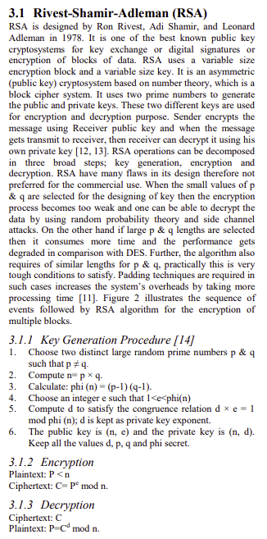
https://ieeexplore.ieee.org/abstract/document/7030724?casa_token=BcIPeImRr2EAAAAA:uum8YbAaxi5k1Rx4K6CAKDRDAi6yUlEx8k2FIkAU7HBT8K8rBXxuhkJS9OM_DzXy3hv4Kd9k4A
